Tuesday, September 5, 2023

8:07 AM

Git Commands

* Adding, committing, pushing a file

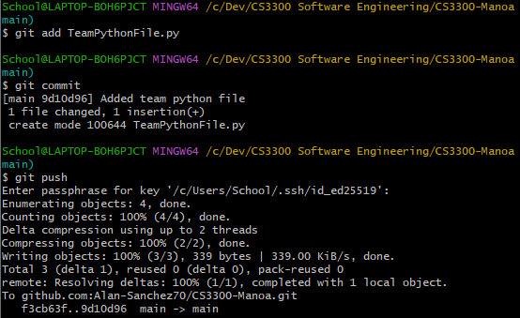

* Copying a file from one branch to another
* 

Saving changes in Git:

<https://www.atlassian.com/git/tutorials/saving-changes>

Merging Branches in Git:

<https://www.atlassian.com/git/tutorials/using-branches/git-merge>

Git Tags:

<https://www.atlassian.com/git/tutorials/inspecting-a-repository/git-tag>